**MADHAN KUMAR B REGISTER NO:231901028**

**EXPERIMENT: 1**

**DATE: 26.07.2024**

**CREATION OF DATABASE AND DML OPERATIONS**

1. Create MY_EMPLOYEE table with the following structure

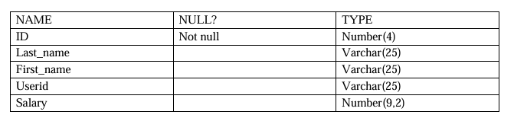

Create table my_employee(ID number(4),Last_name varchar (25),First_name varchar(25),userid varchar(25),salary number(9,2));

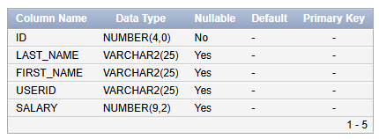

1. Add the first and second rows data to MY_EMPLOYEE table from the following sample data.

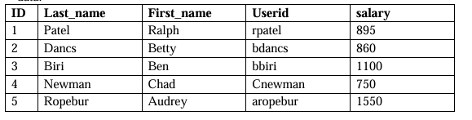

insert into my_employee(Id,Last_name,First_name,userid,salary)

values(1,'patel','Ralph','rpatel',895);

insert into my_employee(Id,Last_name,First_name,userid,salary)

values (2,'dancs','betty','bdancs',860);

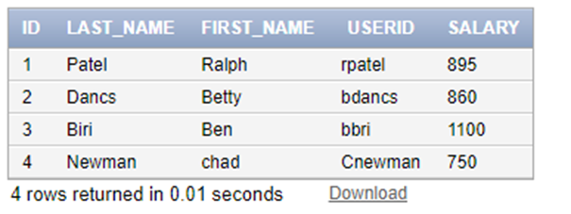

1. Display the table with values

Select *from my_employee

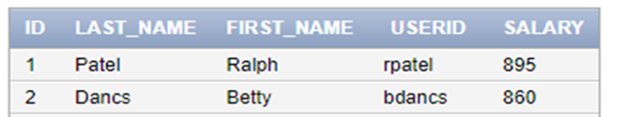

1. Populate the next two rows of data from the sample data. Concatenate the first letter of the first_name with the first seven characters of the last_name to produce Userid.

insert into my_employee(Id,Last_name,First_name,salary)

values (3,'Biri','Ben',1100);

insert into my_employee(Id,Last_name,First_name,salary)

values (4,'Newman','chad',750);

update my_employee

set userid= SUBSTR(first_name, 1, 1) || SUBSTR(last_name,1, 7)



1. Delete Betty dancs from MY _EMPLOYEE table.
2. delete from my_employee where first_name='Betty';

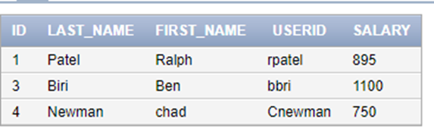

1. Empty the fourth row of the emp table.

delete from my_employee where ID=4;

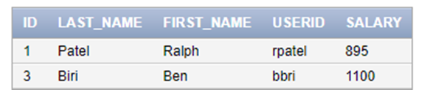

1. Make the data additions permanent.

commit;

1. Change the last name of employee 3 to Drexler.

update my_employee

set last_name='Drexler' where ID=3;

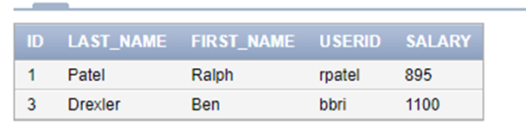

1. Change the salary to 1000 for all the employees with a salary less than 900.

update my_employee

set salary=1000 where salary<900;

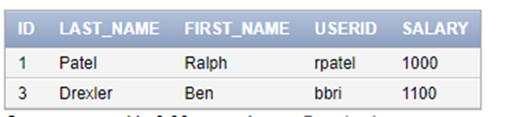

**CSE(CYBER SECURITY)**